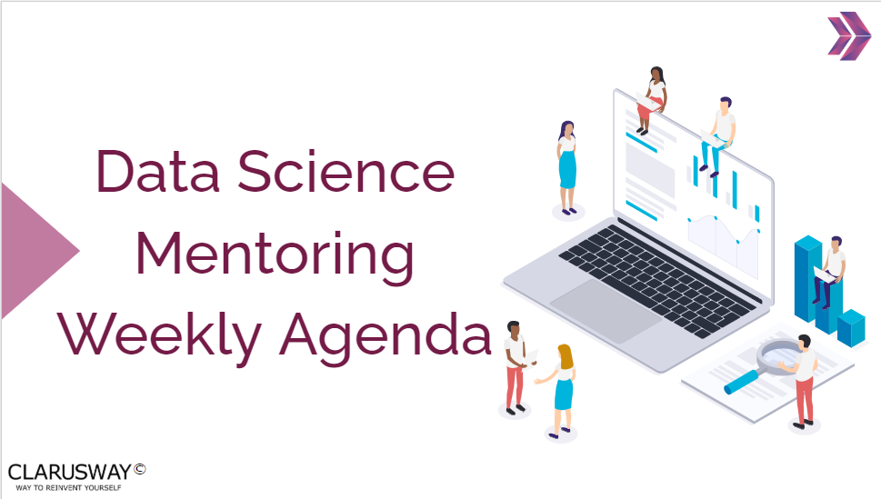

*05 – July – 2022 – Week 8*

The problems and subjects in this part, has been prepared especially for you to equip yourself for the interview process and improve your coding skills. To get the most from this part, it’s highly recommended to be prepared and present the topics in English / German.

At first, it can be difficult to present in English / German and you can read from your notes, no problem. We strongly advise you to force yourself to present especially the interview questions in English / German. However, if you don’t feel you can present in English / German, you can do any part in Turkish, that’s no problem too.

Please remember; we don’t want to put extra pressure to anyone, it’s totally up to you how you prepare for this section. The main and only aim of this part is to develop your skills that you need during and after the recruitment process and make you ready for the DS career.

**Questions Related to Course Topics**

Problems, interview questions and related course topics within the week or sprint term.

**1. Please work on the Probability and Binomial Distribution related Problems below.**

* Probability and Binomial Distribution related Problems (in GitHub)

**2. Please read the article below**

* [Article](https://kueilaramos.medium.com/understanding-relational-database-part-1-4a56c29f9b09)

**Interview Questions Related to Course Topics**

### **3. What is the law of large numbers in statistics?**

### **4. What is Relational Database Management System (RDBMS)?**

|  |  |  |
| --- | --- | --- |
| **Project Discussion** |  |  |

* [Statistics - Assignment -](https://lms.clarusway.com/calendar/view.php?view=day&course=7395&time=1656907140#event_15664) 2
* [Statistics - Assignment –](https://lms.clarusway.com/calendar/view.php?view=day&course=7395&time=1657079940#event_15667) 3
* <https://www.kaggle.com/code/shashwatwork/guide-to-statistical-hypothesis-tests-in-python/notebook>
* <https://www.kaggle.com/code/hamelg/python-for-data-24-hypothesis-testing/notebook>
* <https://www.kaggle.com/code/bharath25/hypothesis-testing-and-predictive-analysis/notebook>